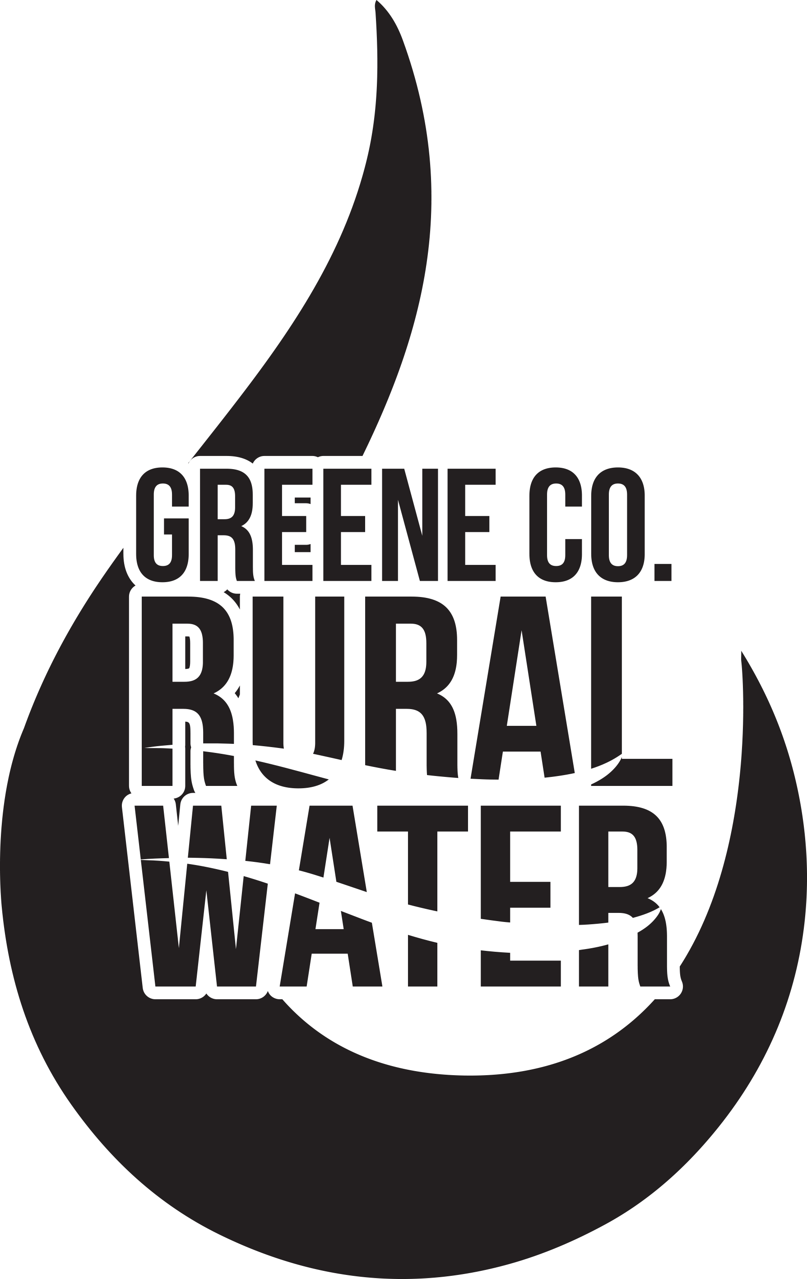

Phone: 217-942-3503
Fax: 217-942-6346
Emergency: 217-248-6292

WWW.GCRWD.ORG

451 Michelle Ln
Carrollton, IL62016

Dear Resident,
Please complete the form below if you are interested in potentially connecting to Greene County Rural Water in the future. This form will help us communicate with customers interested in water services during the start of a new Phase of construction.
______ YES, I would be interested in having rural water.
______ No, I would not be interested in having rural water.
We will be using these responses to determine areas with the most interest in water service within the county. This will most likely determine the location of several future phases of water installations.
Please mail or bring this form to the Greene County Rural Water District office, 451 Michelle Ln, Carrollton, IL 62016 as soon as possible. Should you have any questions or concerns, please feel free to call our office at 217- 942-3503.
User Location: Town ______________________________
Township ______________________________
Quarter Section ______________________________
Name: ______________________________________________________
Address: ______________________________________________________
Telephone: ______________________________________________________
Sincerely,
Cassie J Cox
Secretary- Treasurer

